Lee Yan Cheng A0199141B

<https://github.com/yanchenglee98/OTOT-A1>

Task A1.1

Steps to Dockerize:

* cd to /app
* Add the Dockerfile
* Add the docker-compose.yml
* Run in terminal: docker-compose up –d –build
  + Or run: docker build . -t <your username>/node-web-app
  + Then run: docker run –p 3000:3000 –d my-app/taska11
* Go to localhost:3000

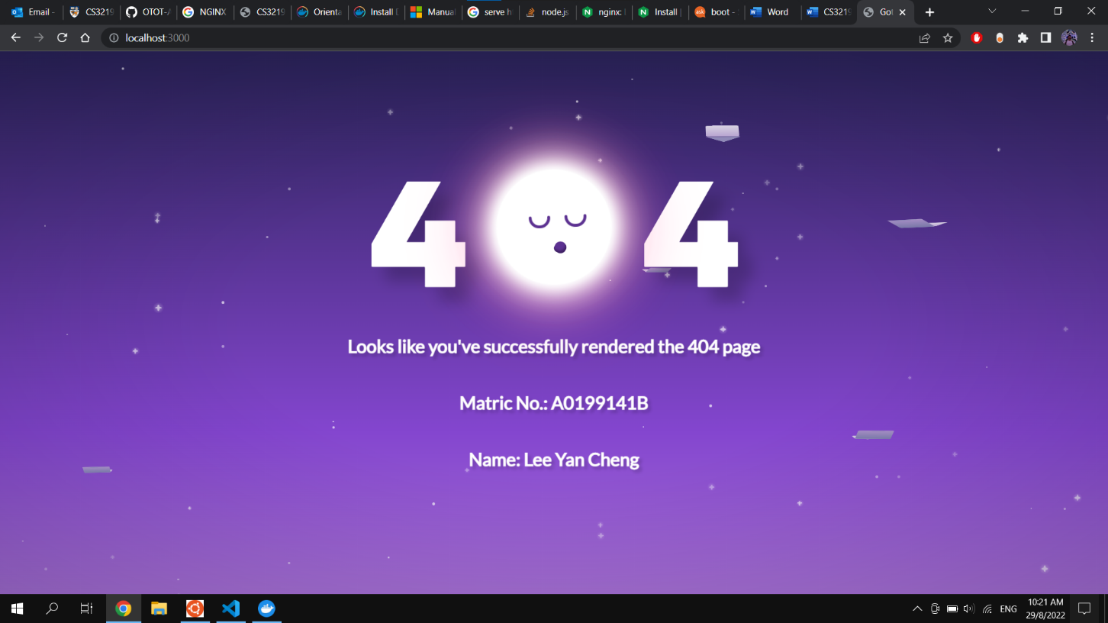

Task A1.2

* cd /nginx-sample
* Create the Dockerfile
* Run in terminal to build image: docker build . -t taska12 .
* Run in terminal to run the container: docker run --name testa12 -p 80:80 -d taska12

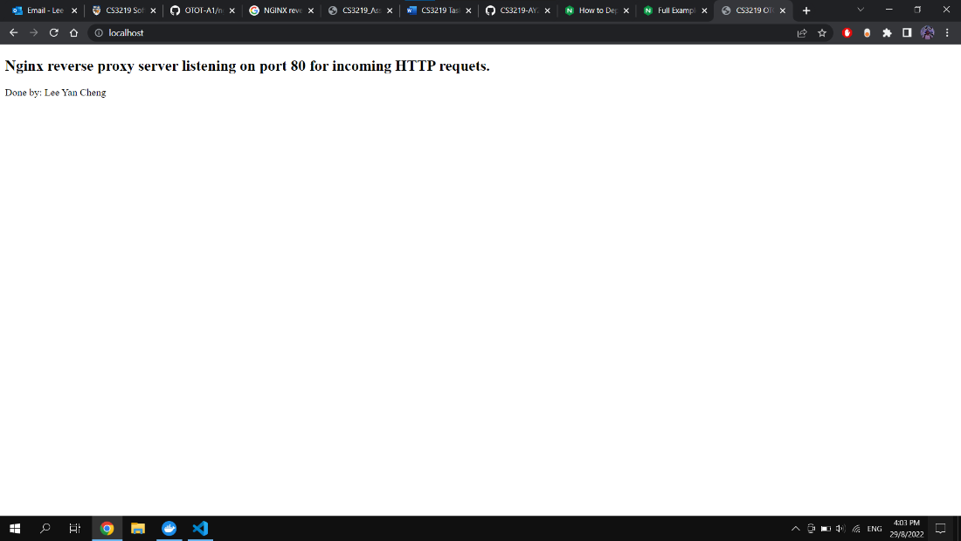

Task A1.3

* cd /nginx
* Create Dockerfile in app folder
* Create default.conf in nginx folder
* Create Dockerfile in nginx folder
* Create docker-compose.yml in /nginx folder to run both containers
* Run in terminal: docker-compose up –build
* Go to localhost:80

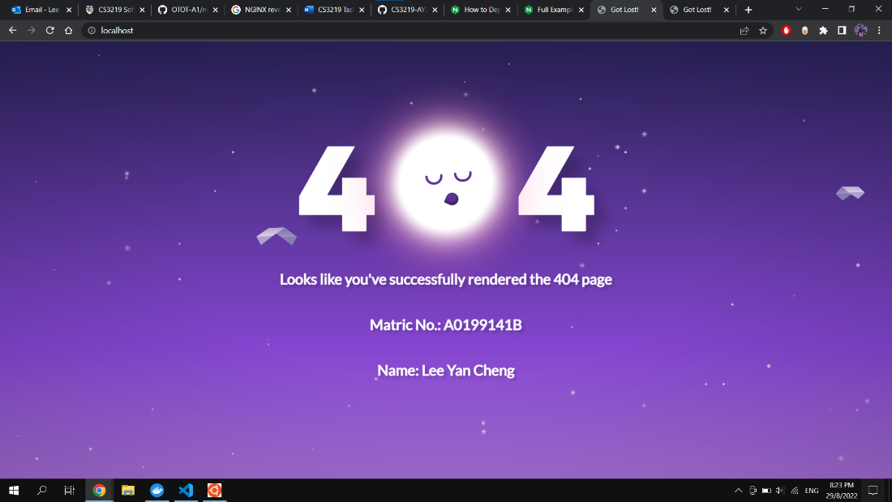

Reverse proxy using localhost:80